JTAG:

Boundary Scan
The main advantage offered by utilising boundary scan technology is the ability to set and read the values on pins without direct physical access.
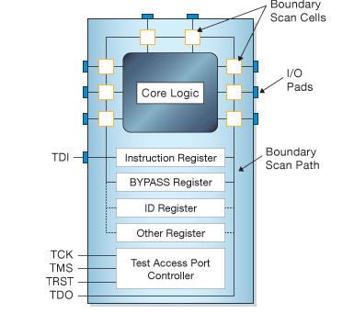

->All the signals between the device’s core logic and the pins are intercepted by a serial scan path known as the Boundary Scan Register (BSR) which consists of a number of boundary scan ‘cells’.

In normal operation these boundary scan cells are invisible. However, in test mode the cells can be used to set and/or read values from the device pins (or in ‘internal’ mode from values of the core logic.) Not all boundary scan cells are the same – there are 10 types of cell in the 1149.1 standards, though manufacturers can define non-standard cell types to match the actual hardware functionality of their device if they wish.

Interface Signals
The JTAG interface, collectively known as a Test Access Port, or TAP, uses the following signals to support the operation of boundary scan.
- TCK (Test Clock) – this signal synchronizes the internal state machine operations.
- TMS (Test Mode Select) – this signal is sampled at the rising edge of TCK to determine the next state.
- TDI (Test Data In) – this signal represents the data shifted into the device’s test or programming logic. It is sampled at the rising edge of TCK when the internal state machine is in the correct state.
- TDO (Test Data Out) – this signal represents the data shifted out of the device’s test or programming logic and is valid on the falling edge of TCK when the internal state machine is in the correct state.
- TRST (Test Reset) – this is an optional pin which, when available, can reset the TAP controller’s state machine.

Registers
There are two types of registers associated with boundary scan. Each compliant device has one instruction register and two or more data registers.
Instruction Register – the instruction register holds the current instruction. Its content is used by the TAP controller to decide what to do with signals that are received. Most commonly, the content of the instruction register will define to which of the data registers signals should be passed.
Data Registers – there are three primary data registers, the Boundary Scan Register (BSR), the BYPASS register and the IDCODES register. Other data registers may be present, but they are not required as part of the JTAG standard.
- BSR – this is the main testing data register. It is used to move data to and from the I/O pins of a device.
- BYPASS – this is a single-bit register that passes information from TDI to TDO. It allows other devices in a circuit to be tested with minimal overhead.
- IDCODES – this register contains the ID code and revision number for the device. This information allows the device to be linked to its Boundary Scan Description Language (BSDL) file. The file contains details of the Boundary Scan configuration for the device.

Test Access Port (TAP) Controller
The TAP controller, a state machine whose transitions are controlled by the TMS signal, controls the behaviour of the JTAG system. Figure 2, below, shows the state-transition diagram.

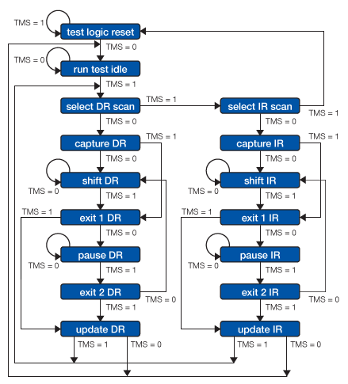

All states have two exits, so all transitions can be controlled by the single TMS signal sampled on TCK. The two main paths allow for setting or retrieving information from either a data register or the instruction register of the device. The data register operated on (e.g. BSR, IDCODES, BYPASS) depends on the value loaded into the instruction register.
For more detail on each state, refer to the IEEE 1149.1 Standard JTAG document.

Boundary Scan Instructions
The IEEE 1149.1 standard defines a set of instructions that must be available for a device to be considered compliant. These instructions are:
- BYPASS – this instruction causes the TDI and TDO lines to be connected via a single-bit pass-through register (the BYPASS register). This instruction allows the testing of other devices in the JTAG chain without any unnecessary overhead.
- EXTEST – this instruction causes the TDI and TDO to be connected to the Boundary Scan Register (BSR). The device’s pin states are sampled with the ‘capture dr’ JTAG state and new values are shifted into the BSR with the ‘shift dr’ state; these values are then applied to the pins of the device using the ‘update dr’ state.
- SAMPLE/PRELOAD – this instruction causes the TDI and TDO to be connected to the BSR. However, the device is left in its normal functional mode. During this instruction, the BSR can be accessed by a data scan operation to take a sample of the functional data entering and leaving the device. The instruction is also used to preload test data into the BSR prior to loading an EXTEST instruction.
Other commonly available instructions include:
- IDCODE – this instruction causes the TDI and TDO to be connected to the IDCODE register.
- INTEST – this instruction causes the TDI and TDO lines to be connected to the Boundary Scan Register (BSR). While the EXTEST instruction allows the user to set and read pin states, the INTEST instruction relates to the core-logic signals of a device.

https://www.xjtag.com/about-jtag/jtag-a-technical-overview/

Board Building activity of RPI:

THIS PROCEDURE IS FOR RASPBERRY Pi1 ONLY)

https://www.raspberrypi.org/documentation/linux/kernel/building.md

https://www.raspberrypi.org/documentation/installation/installing-images/linux.md

Step for kernel compilation:
_______________________________

1> enable CONFIG_KALLSYMS and CONFIG_DEBUG_INFO in your .config file.
CONFIG_KALLSYMS=y
CONFIG_KALLSYMS_ALL=y

CONFIG_DEBUG_INFO=y
CONFIG_DEBUG_INFO_REDUCED=y
CONFIG_DEBUG_INFO_SPLIT=y
CONFIG_DEBUG_INFO_DWARF4=y
CONFIG_GDB_SCRIPTS=y
CONFIG_ENABLE_WARN_DEPRECATED=y
CONFIG_ENABLE_MUST_CHECK=y
CONFIG_FRAME_WARN=1024

2> set variable KERNEL=kernel
3> make ARCH=arm CROSS_COMPILE=/home/mehul/rpi/tools/arm-bcm2708/arm-bcm2708-linux-gnueabi/bin/arm-bcm2708-linux-gnueabi- bcmrpi_defconfig
4> make ARCH=arm CROSS_COMPILE=/home/mehul/rpi/tools/arm-bcm2708/arm-bcm2708-linux-gnueabi/bin/arm-bcm2708-linux-gnueabi- zImage modules dtbs

Step for U-boot compilation:
____________________________:
*(These commands only if you want to do some changes in U-boot , otherwise placing kernel related images in SDcard will work ,as
raspian has its own bootloader)
1> make ARCH=arm CROSS_COMPILE=/home/mehul/rpi/tools/arm-bcm2708/arm-bcm2708-linux-gnueabi/bin/arm-bcm2708-linux-gnueabi- rpi_defconfig
2> make ARCH=arm CROSS_COMPILE=/home/mehul/rpi/tools/arm-bcm2708/arm-bcm2708-linux-gnueabi/bin/arm-bcm2708-linux-gnueabi-

Putting image into SD card :
_______________________

1> First format the SD card.
2> Then execute command sudo dd if=2017-06-21-raspbian-jessie.img of=/dev/sdd bs=4M .
3> insert the card in the board and boot it once , so that it will create partition.
4> now to get the log on minicom write "enable_uart=1" at the end of /boot/config.txt as mentioned in https://elinux.org/RPi_Serial_Connection.
(in board RPi1-1551 Tx/Rx pin is not working , so please take board RPi1-1550)

go to kernel dirrctory where you compile the code and execute below command(below commands are given in raspberry site also.)
mkdir mnt
mkdir mnt/fat32
mkdir mnt/ext4
sudo mount /dev/sdb1 mnt/fat32
sudo mount /dev/sdb2 mnt/ext4

sudo make ARCH=arm INSTALL_MOD_PATH=mnt/ext4 modules_install

sudo cp mnt/fat32/$KERNEL.img mnt/fat32/$KERNEL-backup.img
sudo cp arch/arm/boot/zImage mnt/fat32/$KERNEL.img
sudo cp arch/arm/boot/dts/*.dtb mnt/fat32/
sudo cp arch/arm/boot/dts/overlays/*.dtb* mnt/fat32/overlays/
sudo cp arch/arm/boot/dts/overlays/README mnt/fat32/overlays/
sudo umount mnt/fat32
sudo umount mnt/ext4

__________________________________________

JTAG pin configuration program:

download JtagEnabler.cpp for Rpi1 from internet and crosscompile it and generate a.out and put executable(./a.out)in the SD card partition.

__________________________________________
Enabling JTAG pins :

After SD card flashed , put it in the board's SD card slot.Then After when kernel boot and you get the prompt, go to the directory where ./a.out was kept and execute it.
$ arm-linux-gnueabi-g++ hello.cc -o hello
https://www.acmesystems.it/arm9_toolchain

username and password to login into board :
username : pi
password : raspberry

___________________________________________

Trace32 :

After making connection as shown in the wiki image , launch trace32 and execute below commnad in t32 prompt.
SYSTEM.CPU ARM1176JZF //processor info to tarce 32
and then as shown in attched image tronchip.png , untick all the exceptions listed under "set" tab .Then execute below command
SYSTEM.CPUACCESS Enable//enabling the cpu
SYSTEM.MODE ATTACH //activating the target
DATA.LOAD.ELF c:\Users\Administrator\Documents\new\linux-rpi-3.10.y\vmlinux /NOCODE
//loading source tree of workspace which we have done in linux machine and loading without target
Y.SPATH.SRD c:\Users\Administrator\Documents\new\linux-rpi-3.10.y\
//loading source path

Symbol.SPATH.List
r(register info)

r.s pc start_kernel// setting program counter value to the staring of kernel

b.s cpu _init(setting break point)

mixed more you can see the both assemly and c code.

http://www2.lauterbach.com/pdf/training_rtos_linux.pdf
Now , you are ready to set the breakpoint and debug ,but this will let you to debug only kernel code in which you have place
breakpoint and if application call that function but you will not able to debug the code which is executing in the start of the kernel
becuase we are enabling JTAG pins after kernel boots ; so to debug at kernel booting level , implement the JtagEnable.cpp logic
before kernel boots at uboot level.

USEFUL LINKS:

https://wiki.globaledgesoft.com/index.php/JTAG_Debugging_on_Raspberry_Pi#Preparing_Rasberry_PI_for_JTAG_.26_README
https://www.raspberrypi.org/documentation/linux/kernel/building.md
http://sysprogs.com/VisualKernel/tutorials/raspberry/jtagsetup/
https://github.com/raspberrypi/linux/tree/rpi-3.10.y
https://elinux.org/RPi_U-Boot
https://github.com/gonzoua/u-boot-pi
https://wiki.globaledgesoft.com/index.php/Raspberry_Pi
https://devsidestory.com/build-a-64-bit-kernel-for-your-raspberry-pi-3/

